SE1

This is the raw data for SE1, only need to show one of these
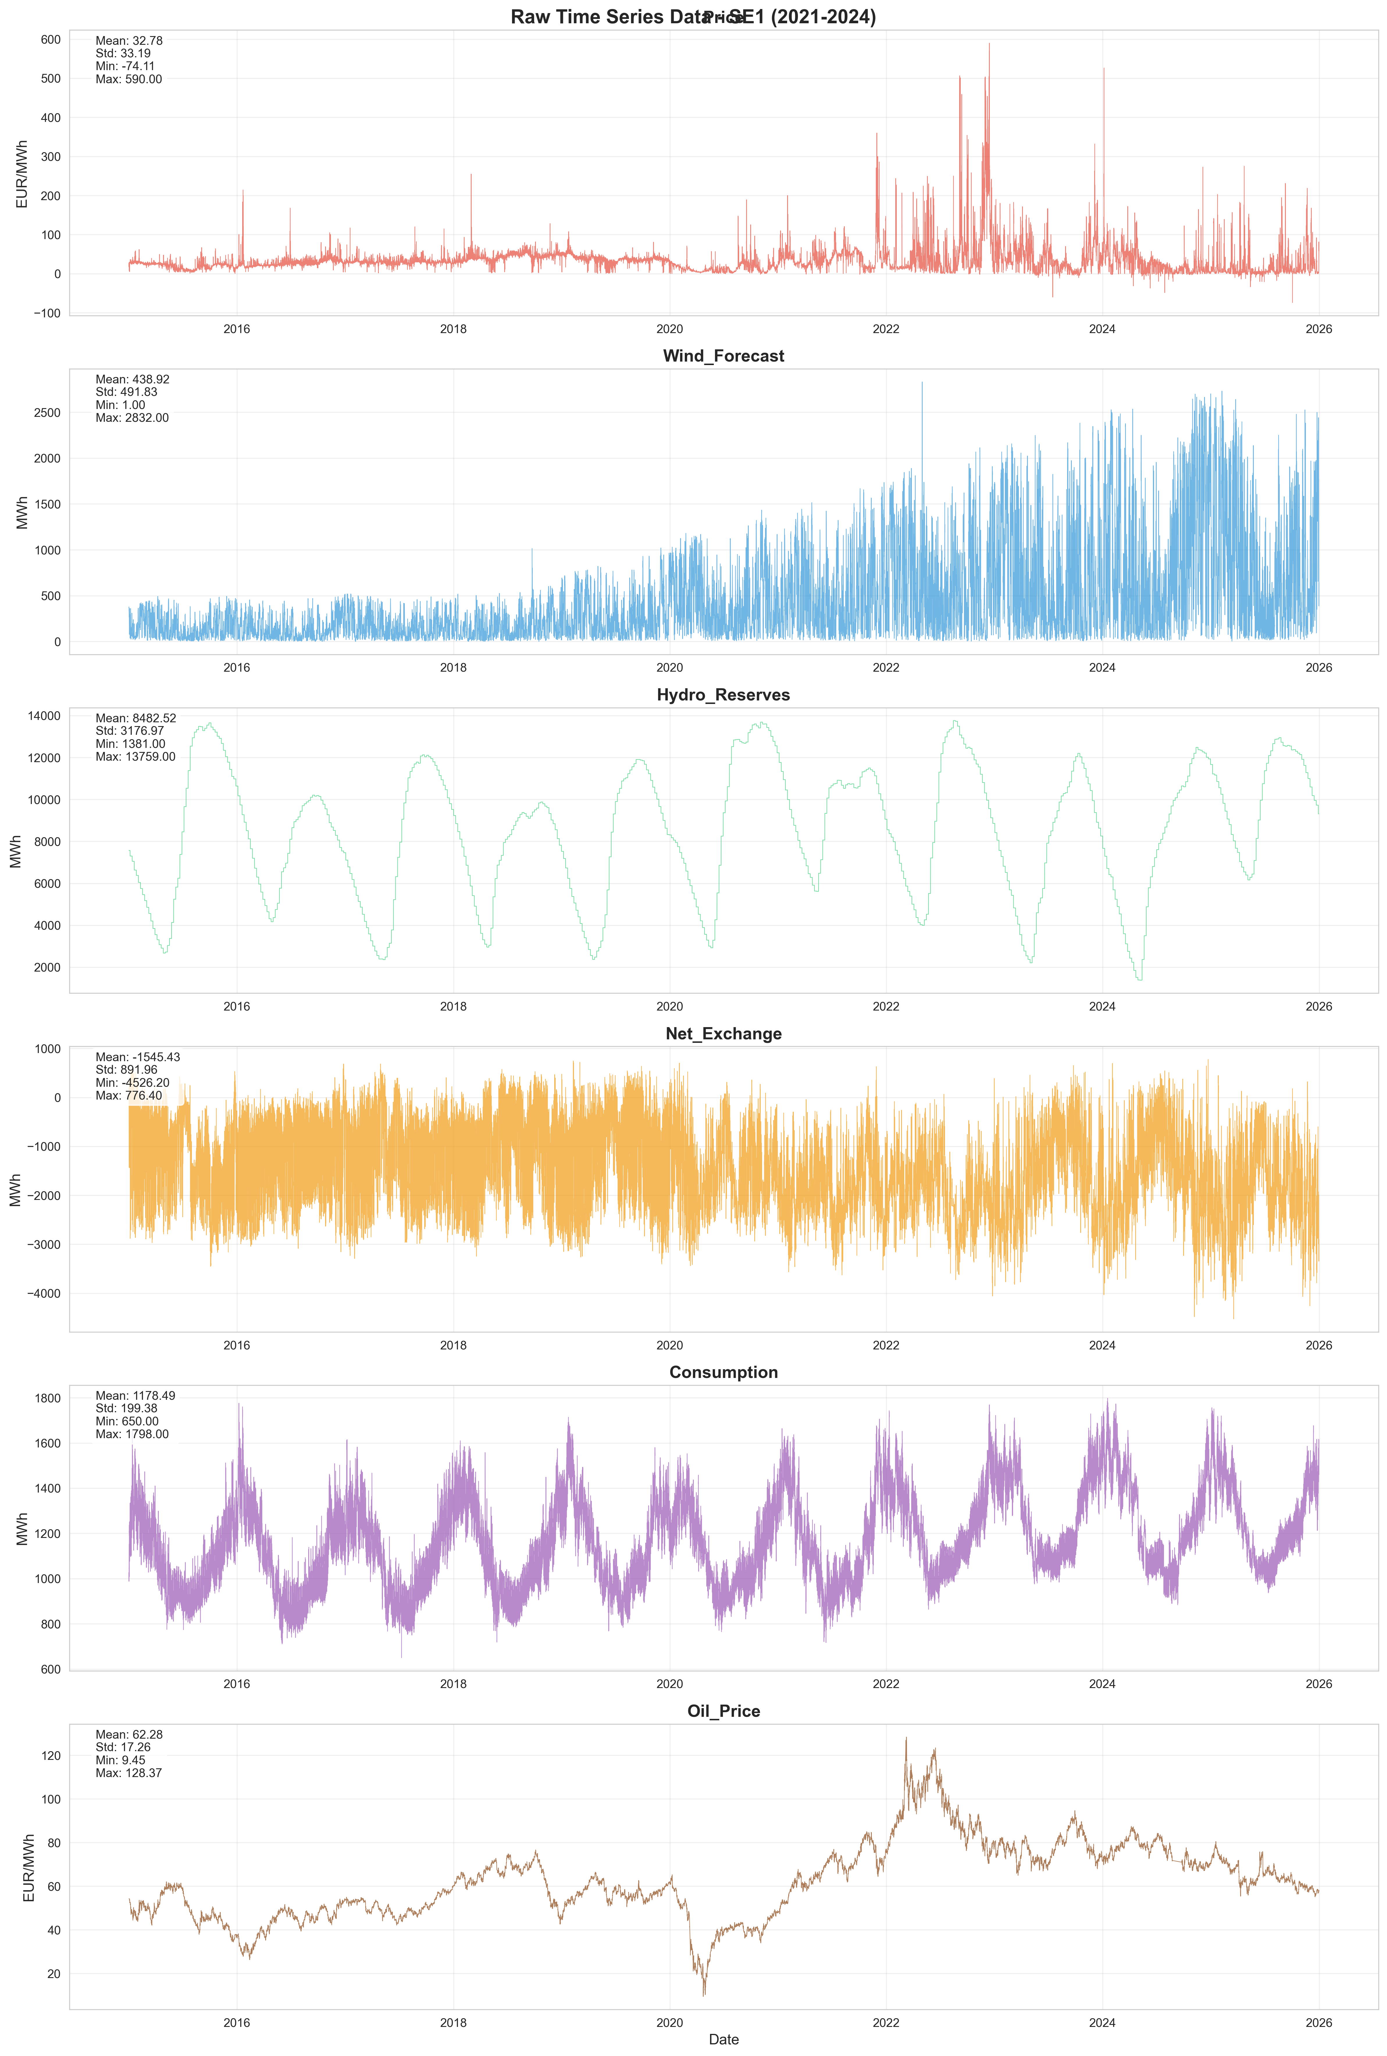

This is the Fredriksson method with shift and logged values
- The method of handling outliers should be remove after logging, given how few negative outliers there are.
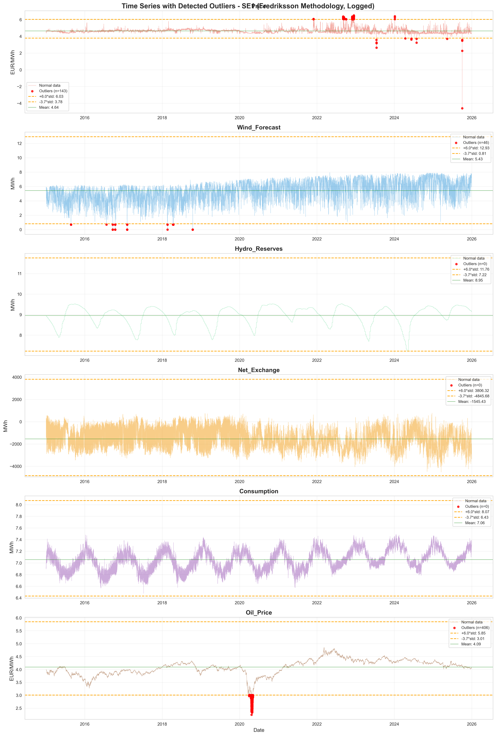
SE1, rolling window analysis:
- 3 year, overlapping, shift 1 year:
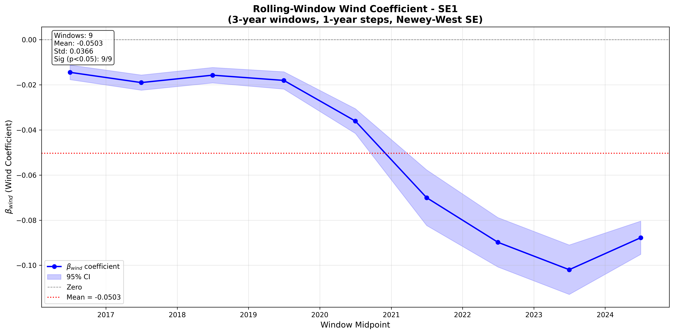
- 1 year, no overlapping, shift 1 year:
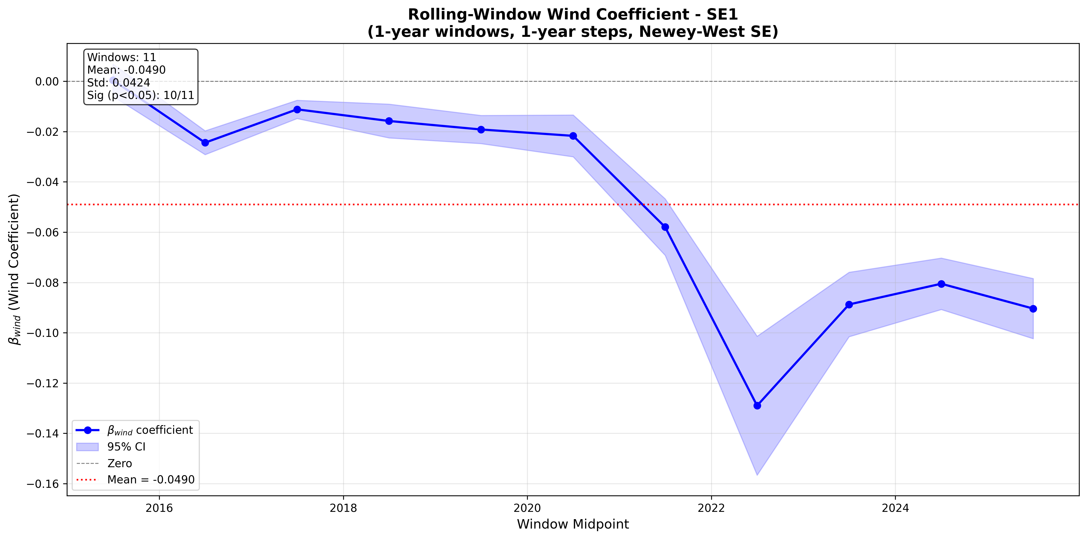
- 1 year, overlapping, shift by 1 month
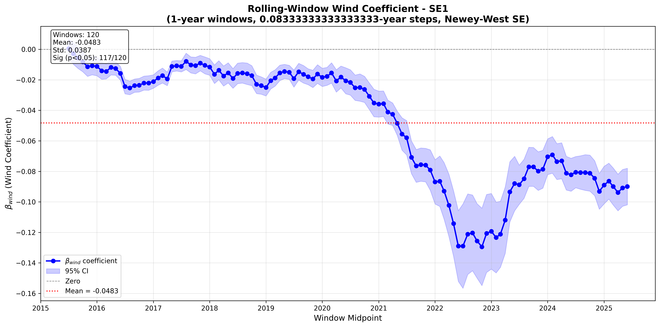

- Structural break analysis, allowing for trend break
  - 1 break allowed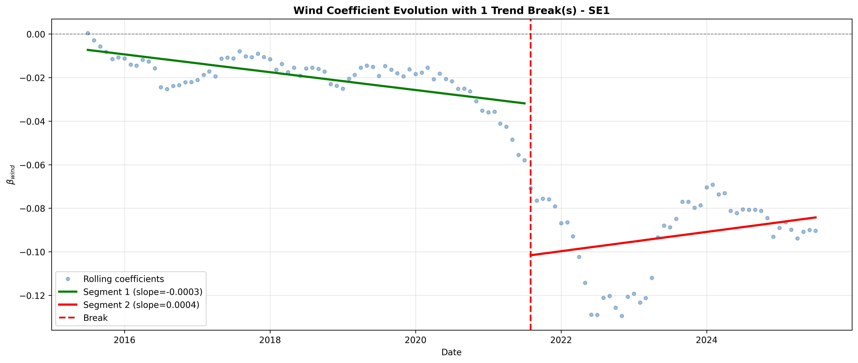
  - 2 breaks allowed
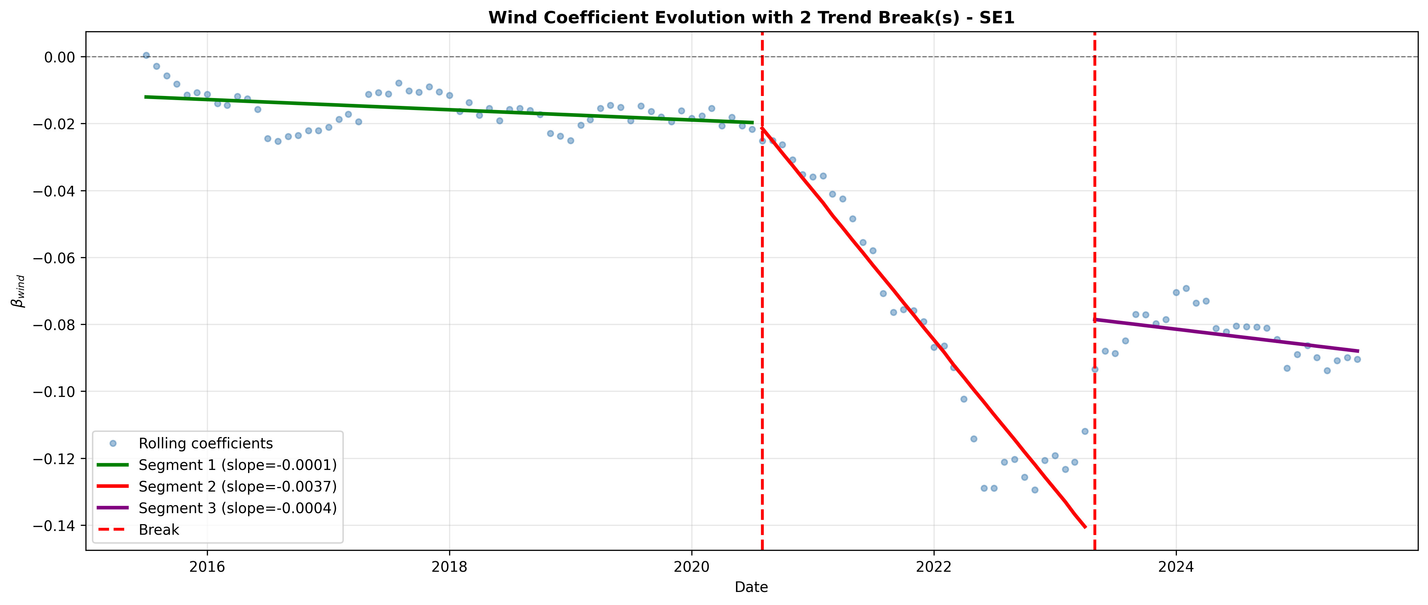
  - 3 breaks allowed
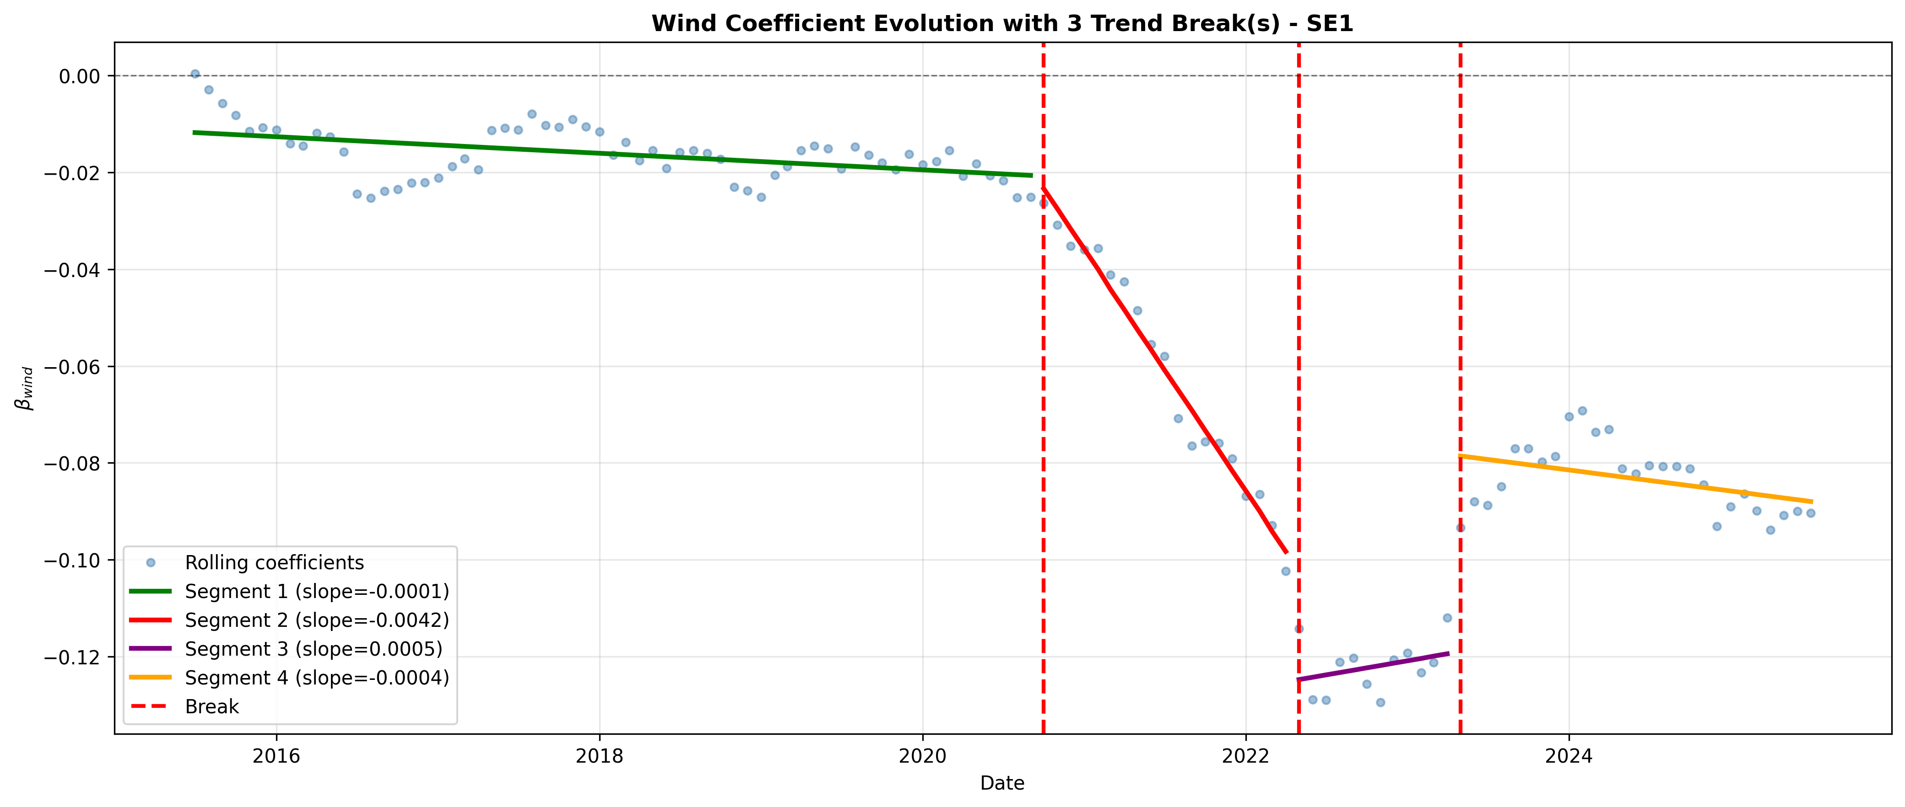

SE2
- 3 year, overlapping, shift 1 year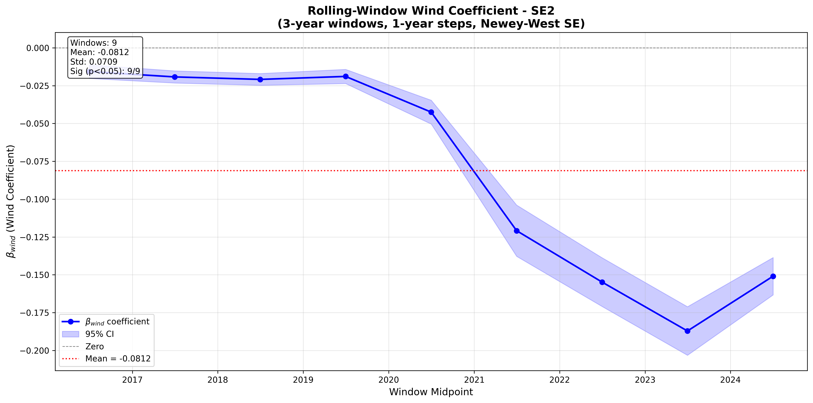
- 1 year, no overlapping, shift 1 year:
- 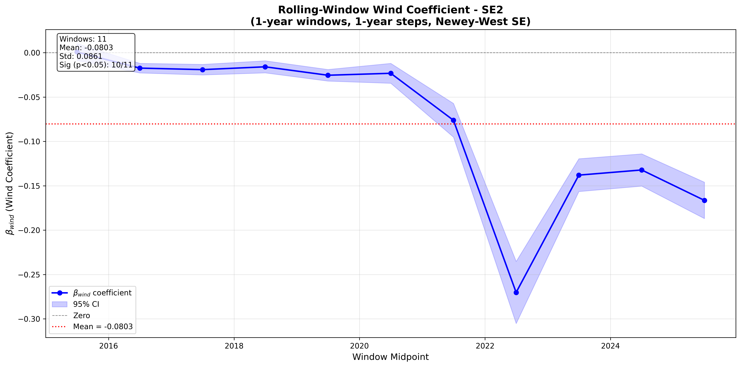

- 1 year, overlapping, shift by 1 month
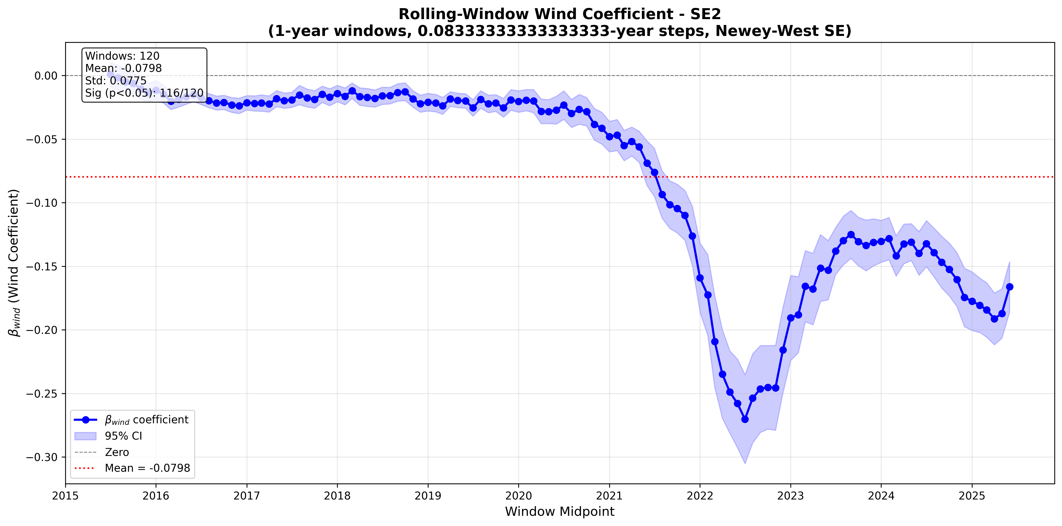
- Structural break analysis, allowing for trend break
  - 1 break allowed
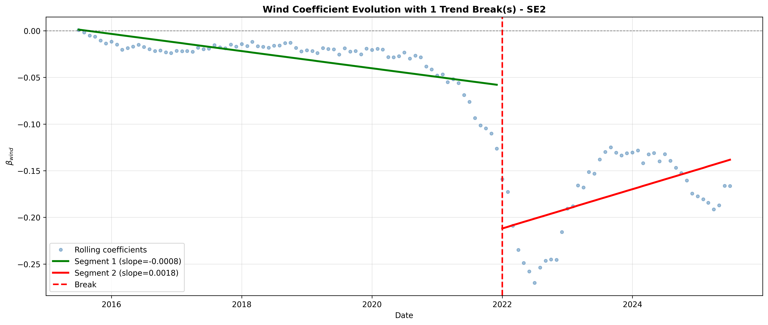
  - 2 breaks allowed
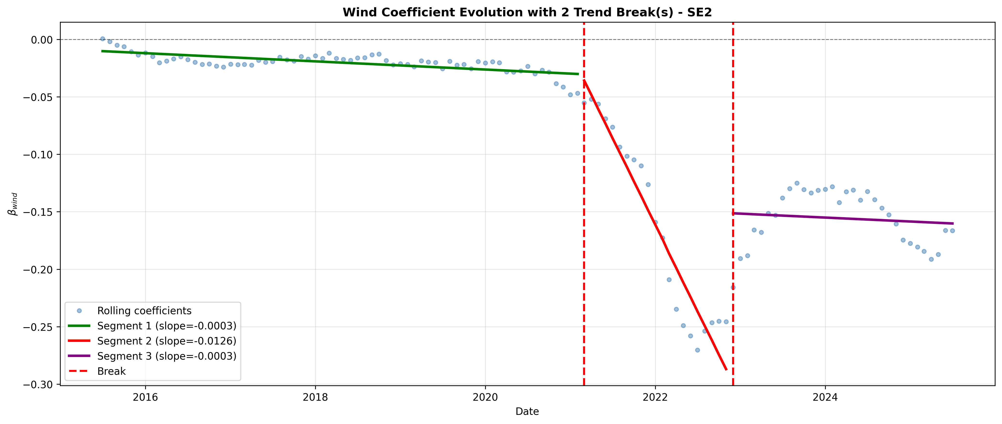

SE3
- 3 year, overlapping, shift 1 year 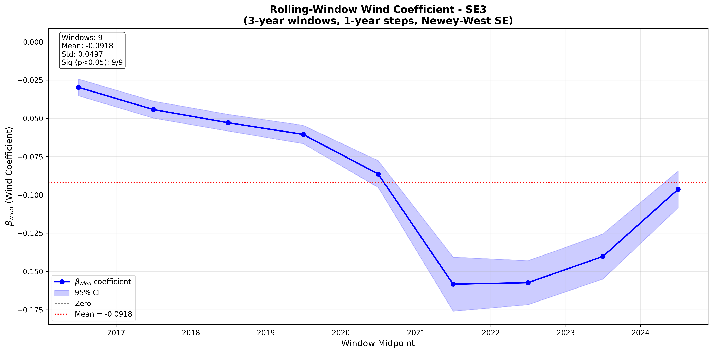
- 1 year, no overlapping, shift 1 year:
- 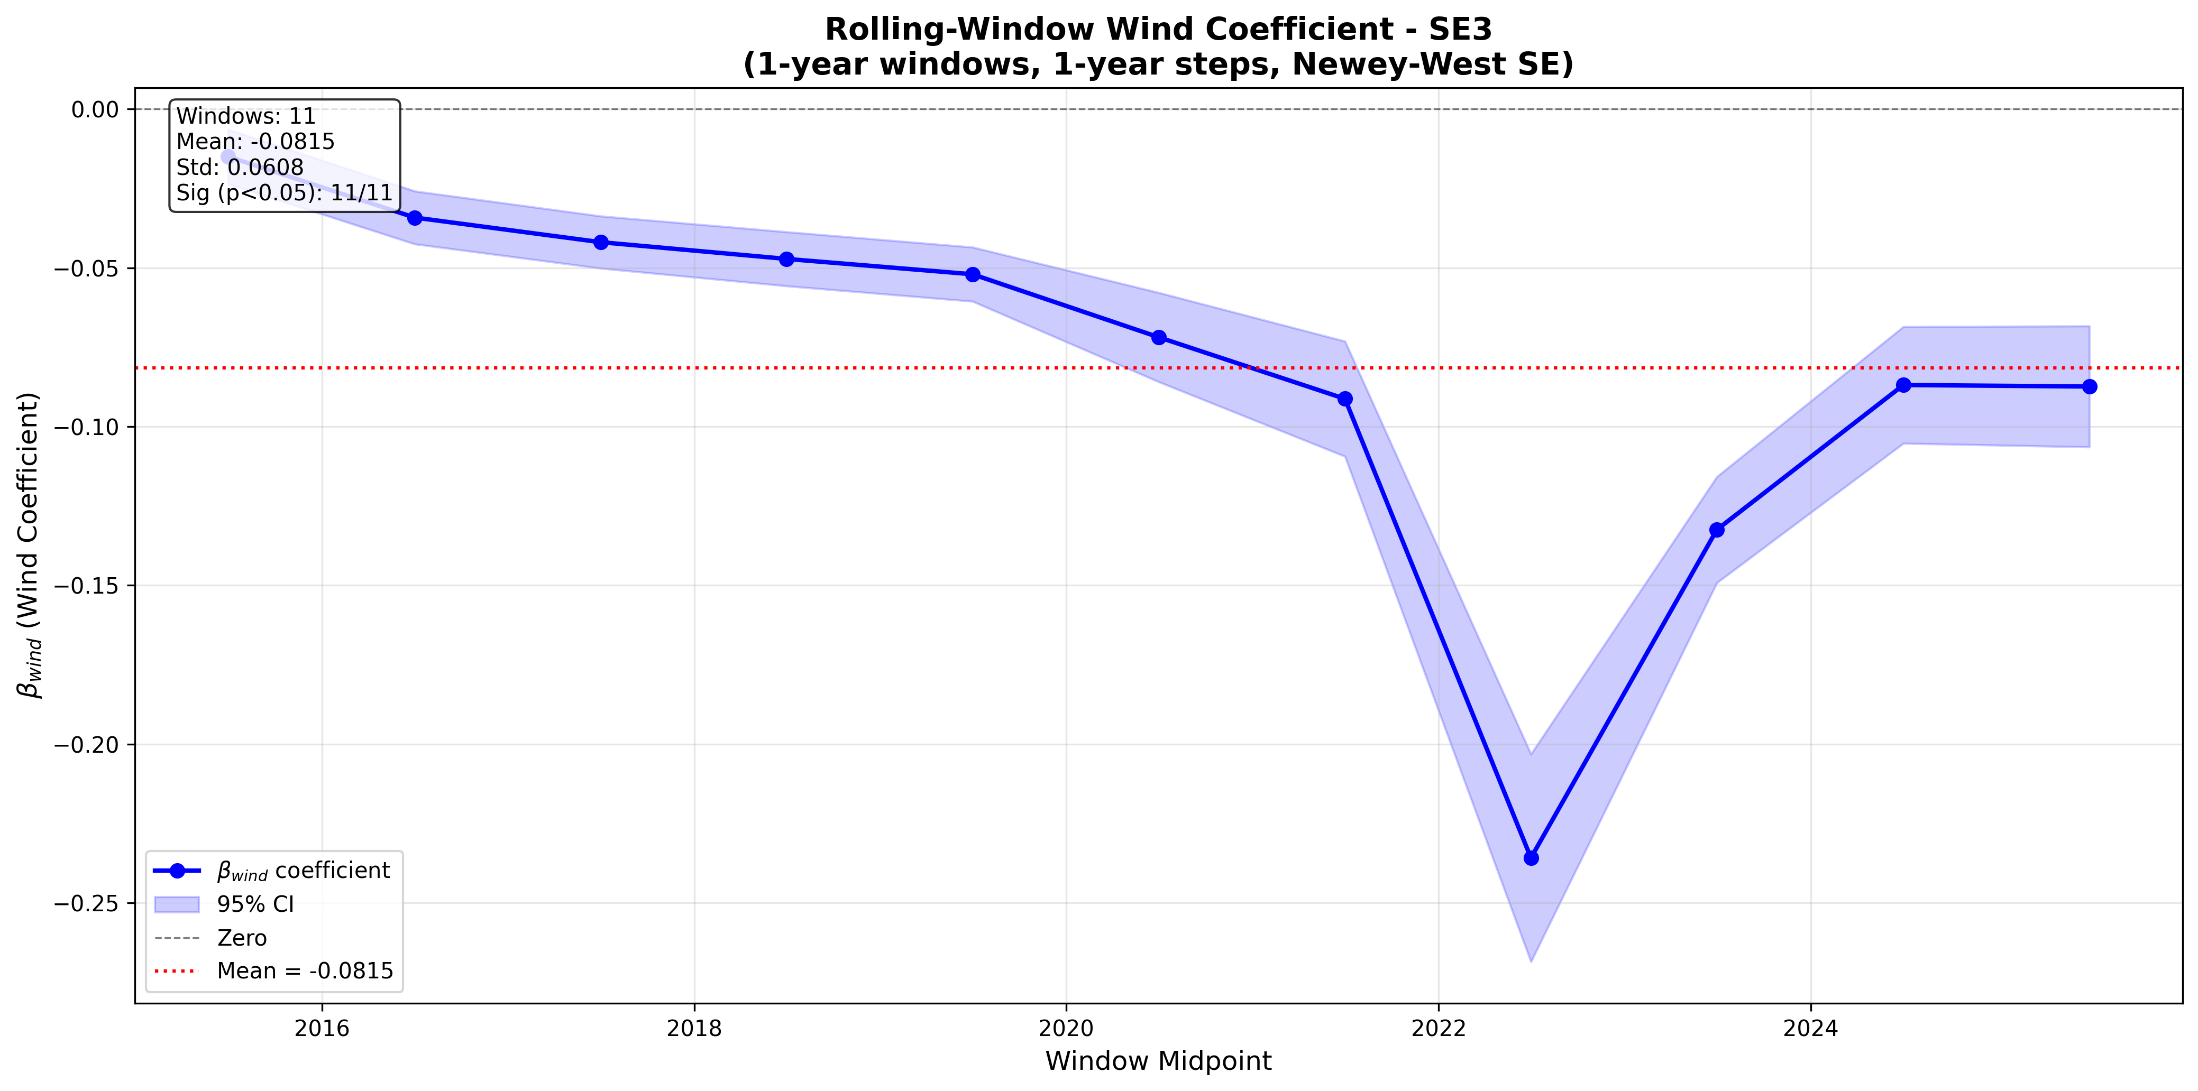

- 1 year, overlapping, shift by 1 month
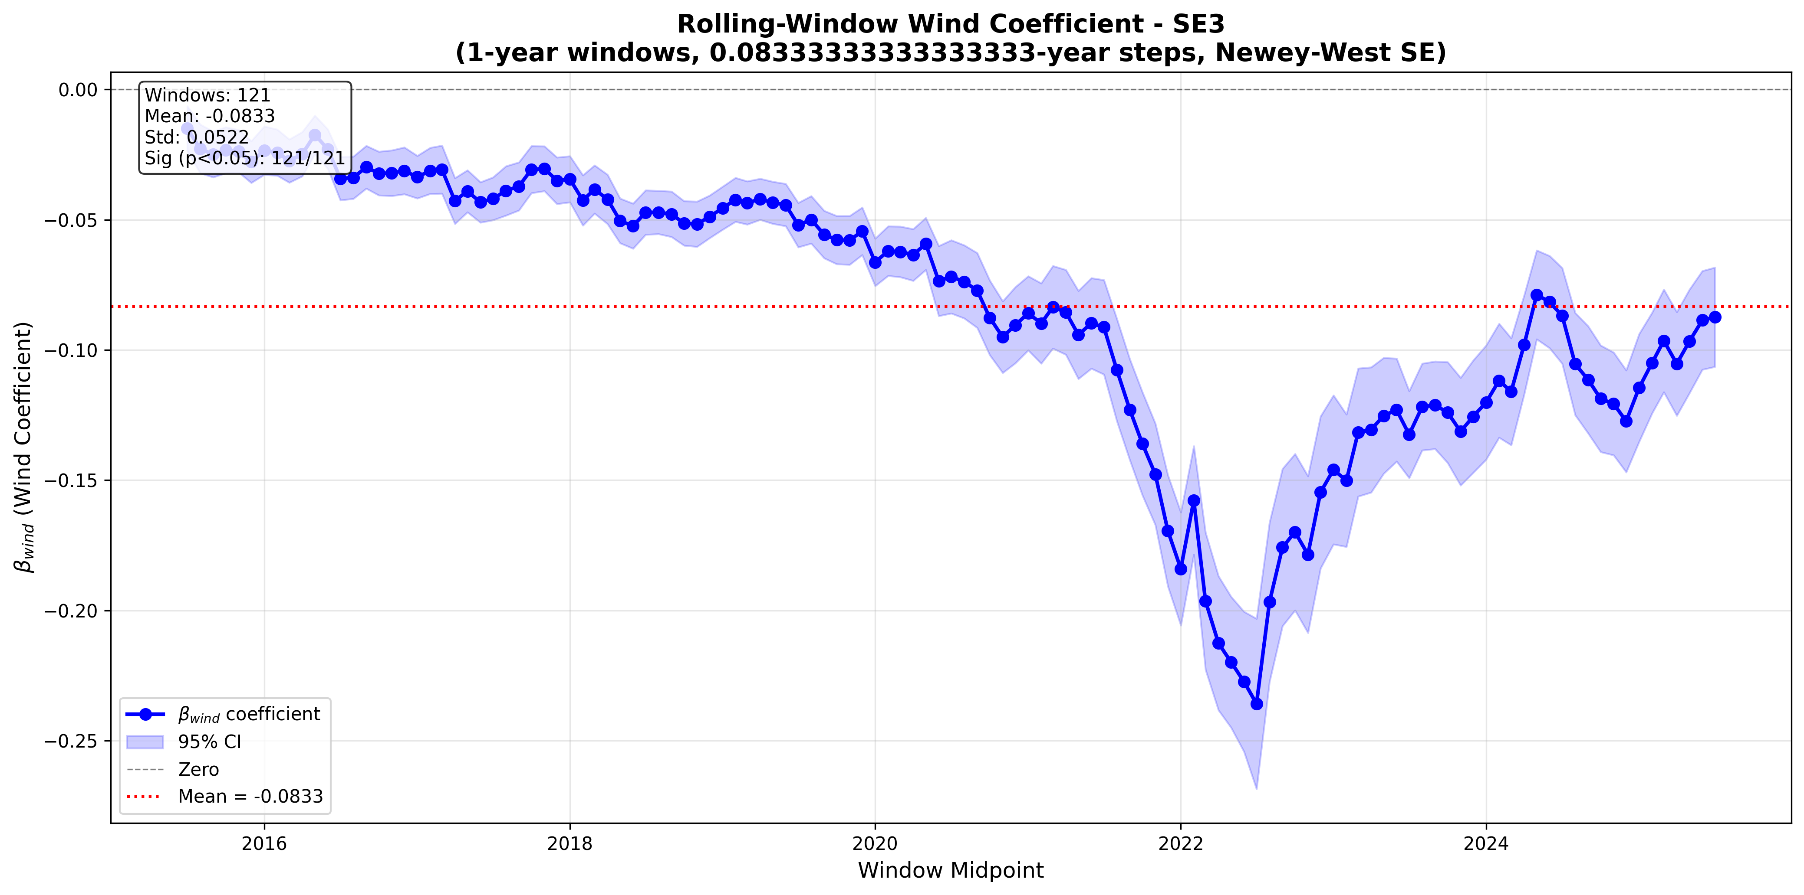
- Structural break analysis, allowing for trend break
  - 1 break allowed
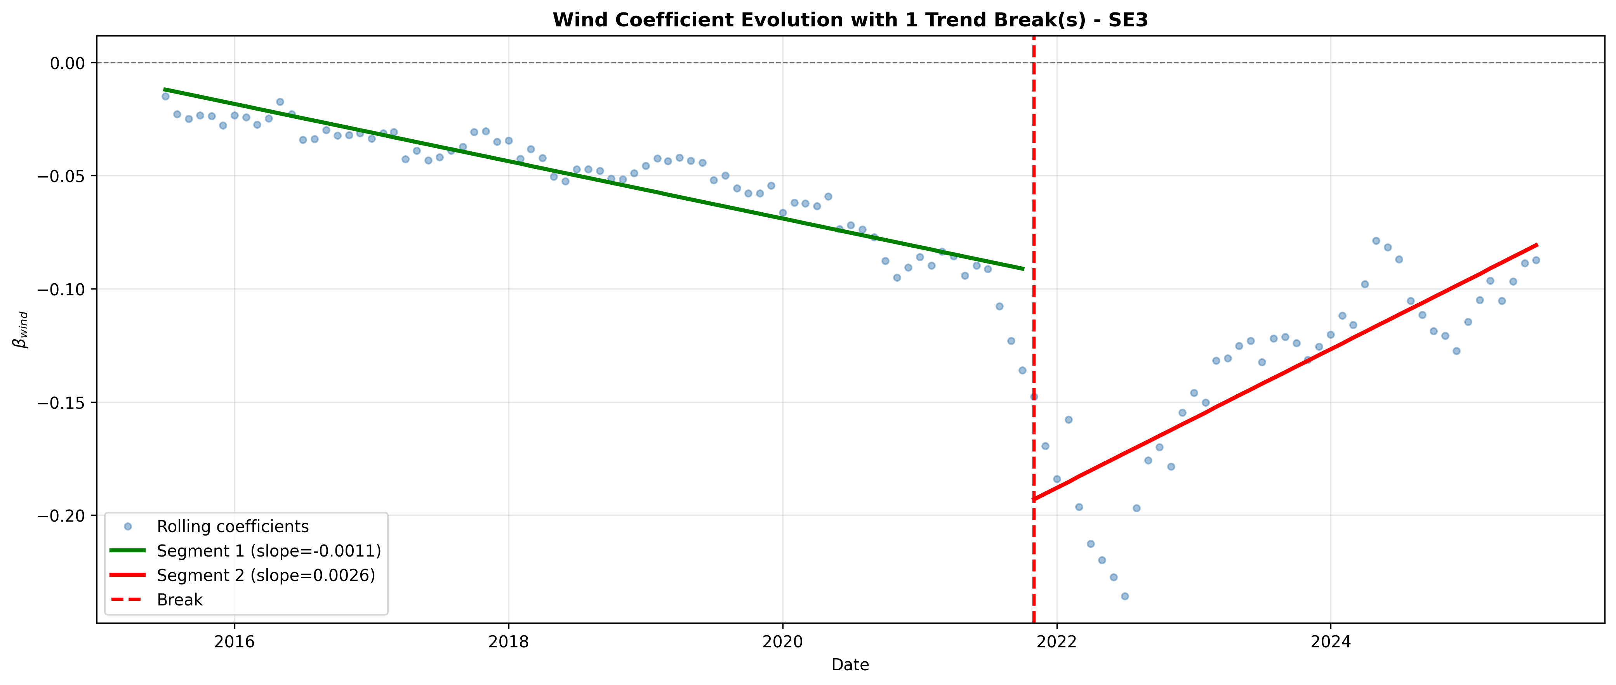
  - 2 breaks allowed
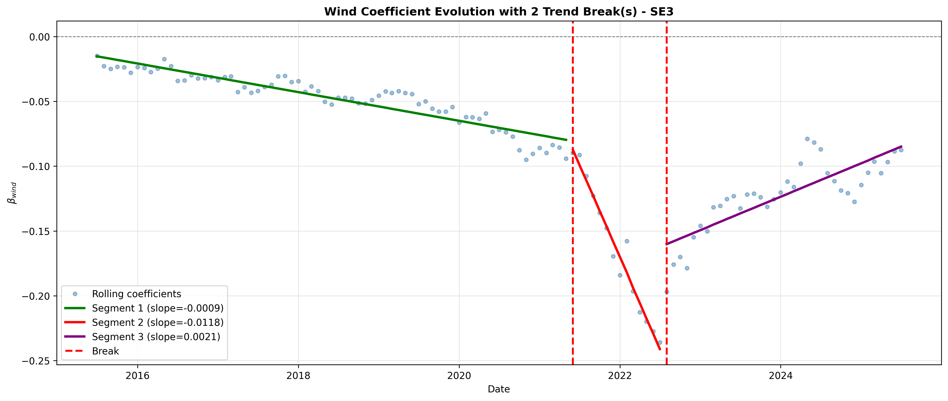

SE4
- 3 year, overlapping, shift 1 year 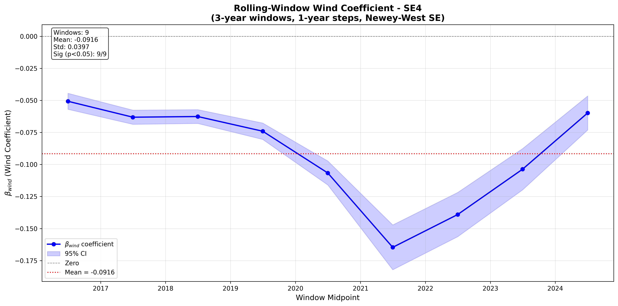
- 1 year, no overlapping, shift 1 year:
- 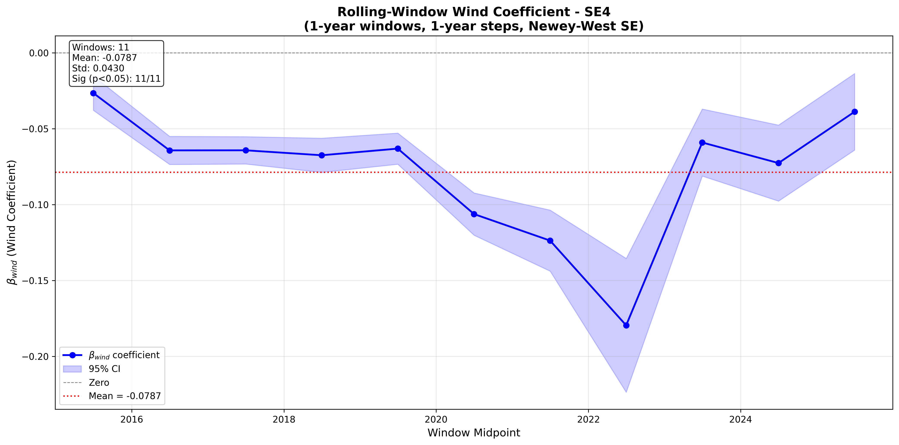

- 1 year, overlapping, shift by 1 month
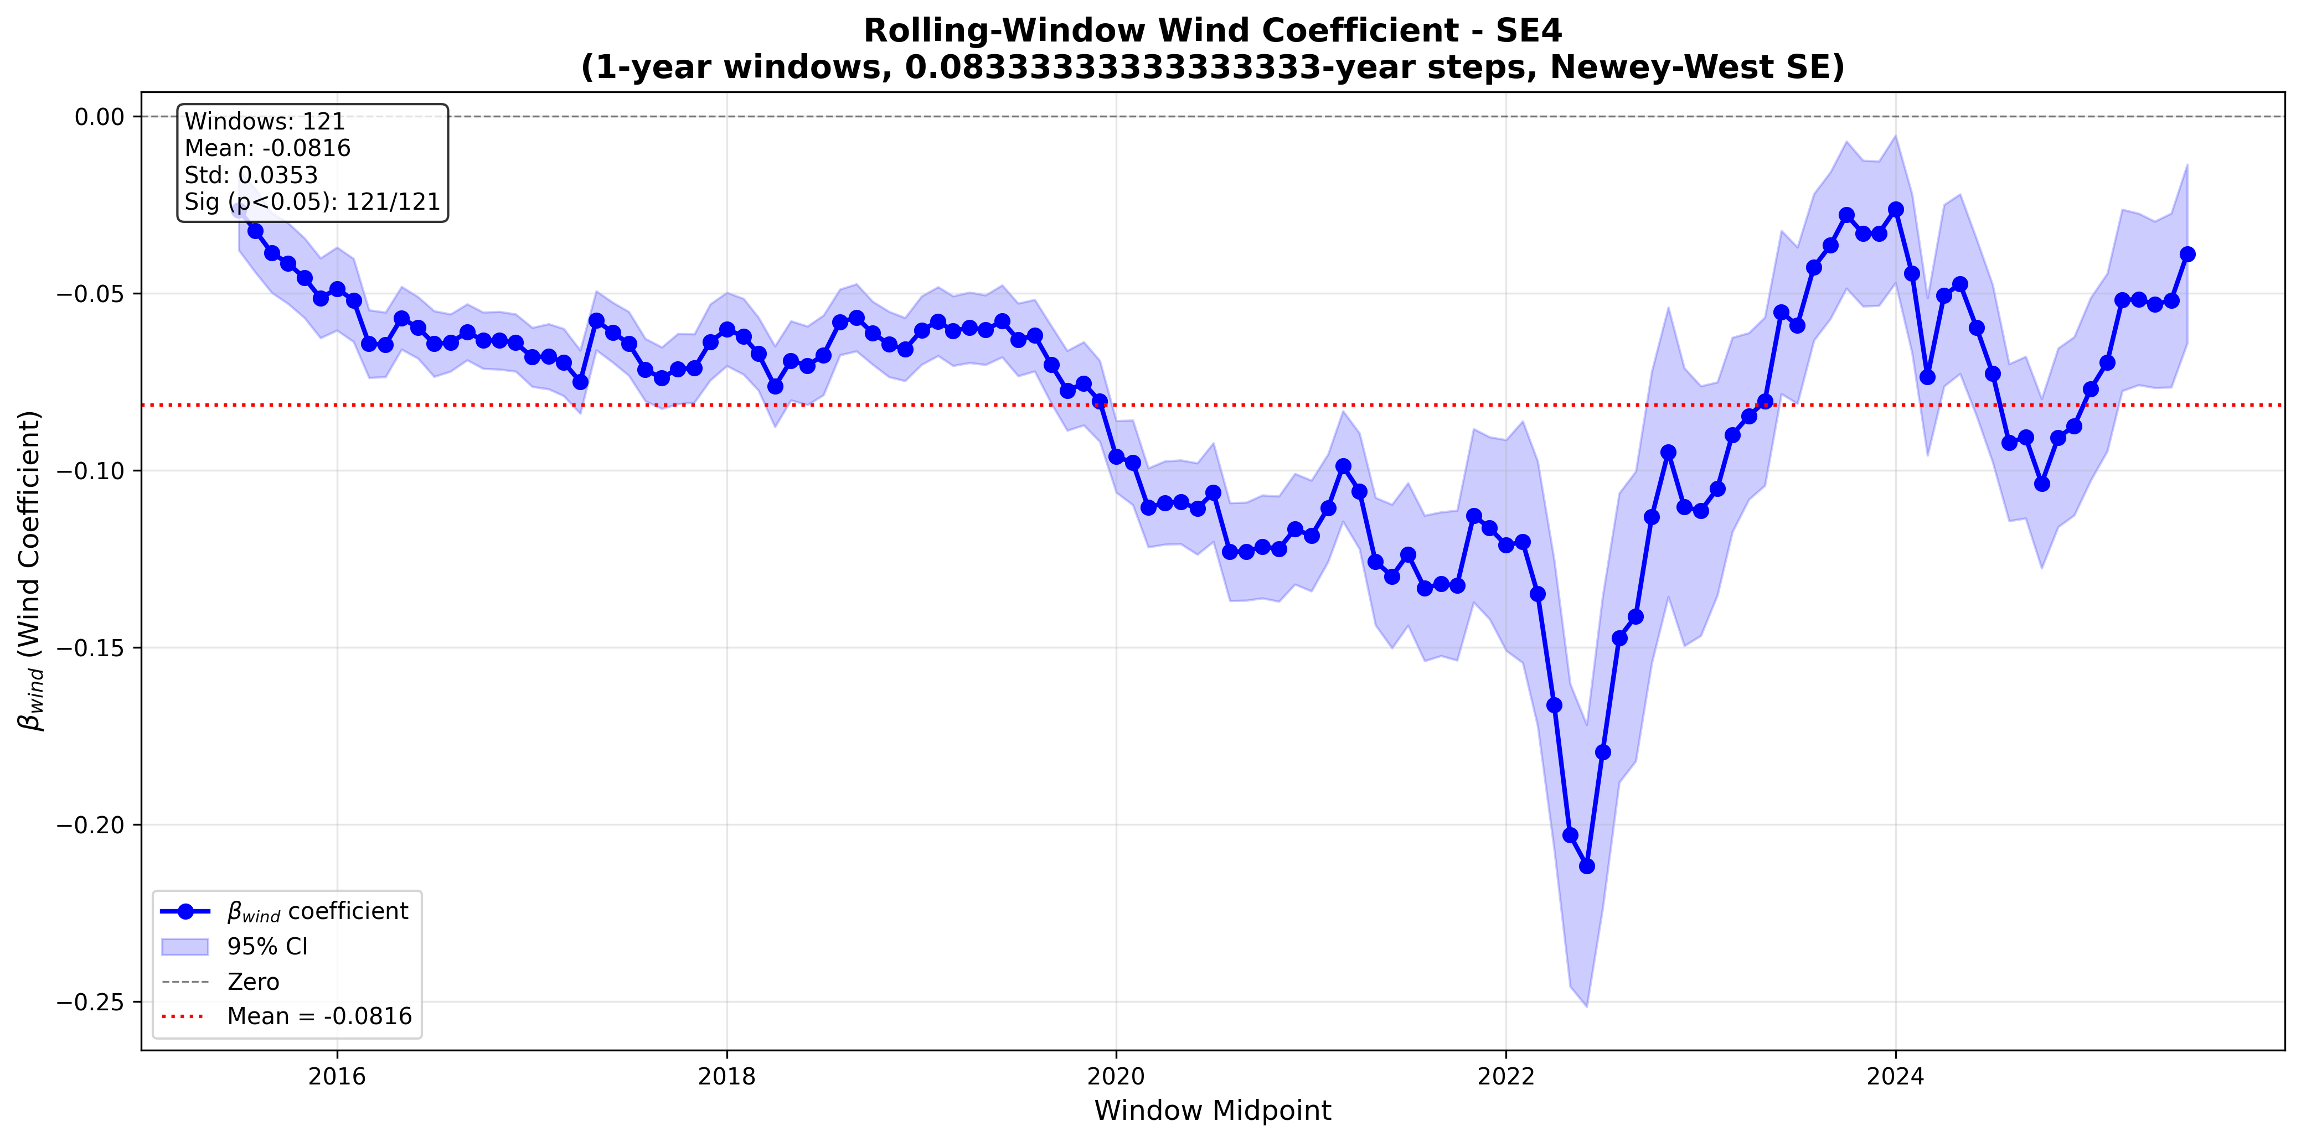
- Structural break analysis, allowing for trend break
  - 1 break allowed
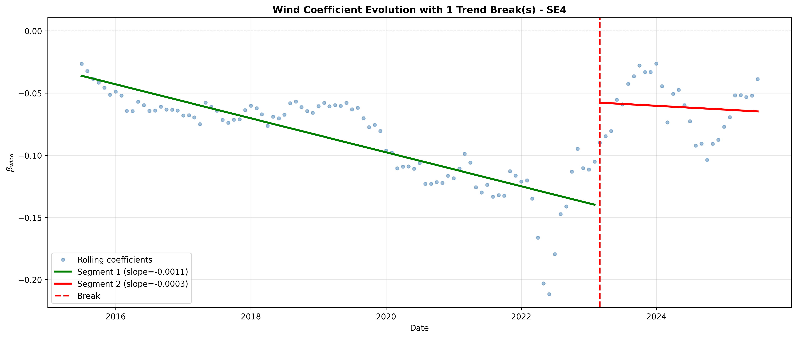
  - 2 breaks allowed
